EVSA1

@ABSTRACT

# coastal and marine waters are frequently polluted by metals that affect the biota.

# Ennore estuary were monitored spatially over two years to understand their potential impact and ecological risk.

# The metal concentrations (μg/l) in the water were in the order of Ni (35) > Pb(16.9) > Cu(15.8) > Cr(12.5) > Cd(5.6) and sediment (μg/g) was Cr(390) > Pb(266) > Cu(162) > Ni(125) > Cd(7.6).

# Dis tinct patterns of metal content in crab, oyster and polychaete (Cu > Cr > Pb > Ni > Cd) and in fish (Pb > Cr > Ni > Cu >Cd).

# Summer months showed higher contamination and risk due to lower water influx and longer residence times.

# Ennore estuary is highly contaminated by Cd and Pb from anthropogenic(environmental change influenced by people ) sources. Which effects the marine system.

# ESTUARIES-bodies of water found where rivers meet the sea.

# PLETHORA- fullness.

@INTRODUCTION

# Coastal estuaries are threatened by urbanization and industrialization which is leading to pollution.

# Metals tend to adsorb from water columns onto surfaces of particles and they are settled into the sediment.

#Metals can be accumulated in the tissues of marine organisms from the water, sediment, suspended particulate materials.

# Bioaccumulation is the indication of bioavailability and it could be a biomarker of metal pollution.

# The Ennore estuary experiences geographical changes at its bar mouth and is impacted by discharge from industries and municipal sewage leading to variable metal availability and distribution in water, sediment and biota.

# Priority metals such as Cu, Cr, Cd, Pd and Ni are increasing globally in inland and coastal waters, especially in developing countries like India.

# In addition the study seeks to investigate the rate of bioaccumulation from ambient water and sediment and assess environmental risks using indices such as contamination factor, Enrichment factor, Geoaccumulation Index, pollution load index and Potential Ecological Risk Index.

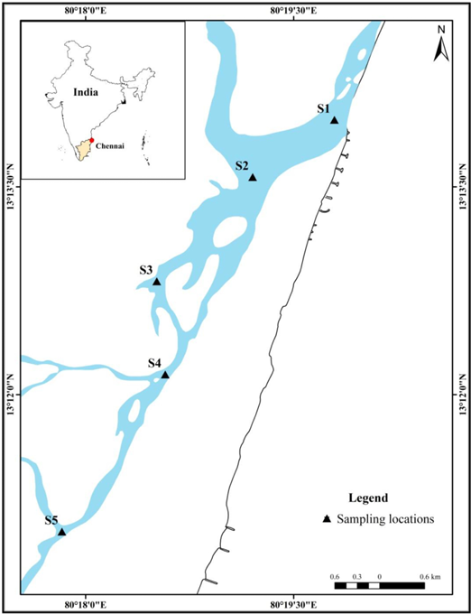

2.1 STUDY AREA

# Ennore estuary is located near the Chennai which is connected with Pulicat lake in the north through Buckingham canal koasthaliyar river in the northwest.

# Anthropogenic activities like industrial, thermal power plants, petrochemicals, automobiles, harbor and suburban residential areas including fishing hamlets are causing pollution in the estuary

#Station-1 Bar mouth is influenced by both freshwater run-off during monsoon and seawater during the diurnal tidal cycle.

#Station-2 In the mid estuary Buckingham canal is the inlet.

# Station-3 is the mid-region of the estuary.

# Station 4 is influenced by the release of wastewaters from the Manali industrial area and also by municipal activities.

# Station 5 is the Inlet of Kosasthalaiyar River which runs for a distance of about 136 km from Vellore town and drains fresh water along with domestic wastewater.

# In Station 4 &5 Tidal flow is very low.and mostly cloudy,black coloured and might release Hydrogen Sulfide.

#Dredging activities are being practiced in the mouth region to facilitate flow of thermal discharge from the Ennore Thermal Power Station to sea.

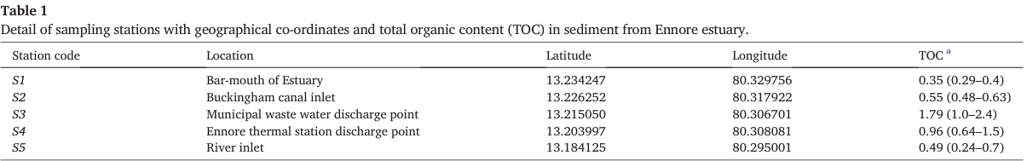

2.2 SAMPLING AND ANALYSIS

#Water, sediment and marine organisms were collected fortnightly for a period of two years (December 2014 to November 2016) from the Ennore estuary.

# In total 480 samples of water and sediment were collected from all the five sampling solutions.

# To determine the seasonal variations of metal concentrations and their risk factor,Samples are cateogorized into four seasons.

1)Post monsoon (July to September)

2) Summer (April to June)

3) Pre-Monsoon (July to September)

4) Monsoon(October to December)

# These samples were processed and analyzed for the metal concentration

- Water samples processed for dissolved metals (Cu, Cd, Cr, Pb, Ni) using standard methods.

- Pre-concentration method involved filtration, acidification, shaking with APDC and MIBK.

- Sediment samples collected, dried, powdered, and subjected to acid digestion.

- TOC in sediment analyzed via Walkley method.

- Marine organism tissues (fish, crab, oyster, polychaete) extracted and analyzed similarly.

- Instrumentation: ICP-OES for water samples, Atomic Absorption Spectrometer for sediment and tissue.

- Analysis validated using certified reference materials for sediment and tissue.

2.3

* Bioaccumulation factor (BAF): Ratio of metal concentration in organism to concentration in water.

2.4

* Biota-Sediment Accumulation Factor (BSAF): Net bioaccumulation of chemicals by organism from environmental source

2.5

* Geoaccumulation Index (Igeo): Measures degree of metal contamination in aquatic sediments.
* Contamination Factor (CF): Indicates contamination level in sediments for specific metals.
* Enrichment Factor (EF): Illustrates degree of anthropogenic pollution.
* Pollution Load Index (PLI): Expresses overall degree of metal pollution in sediment.

2.6

* Potential Ecological Risk Index (PERI): Measures risk of a contaminant in sediment.

3.1 Salinity and TOC

# 0-35psu is the range of salinity in estuarine water.

# If the average salinity in water sample is >5psu in estuarine water referred as seawater.

# 20-35psu is the range of salinity in estuary during summer.

# Salinity is decreasing due to influence of tidal and riverine inputs.

# Salinity dereases from bar mouth towards upstream.

# Highest TOC was found near the sewage discharge point.

# Lowest TOC was found near the barmouth .

3.2 Metal concentration in water

# The concentration of all metals (except Cd) was highest at station S3, which is a sewage discharge point [Table 2].

# The concentration of Cd was highest at station S4 [Table 2].

# The concentration of all metals (except Cu) was lowest at station S1, which is the bar-mouth of the estuary [Table 2].

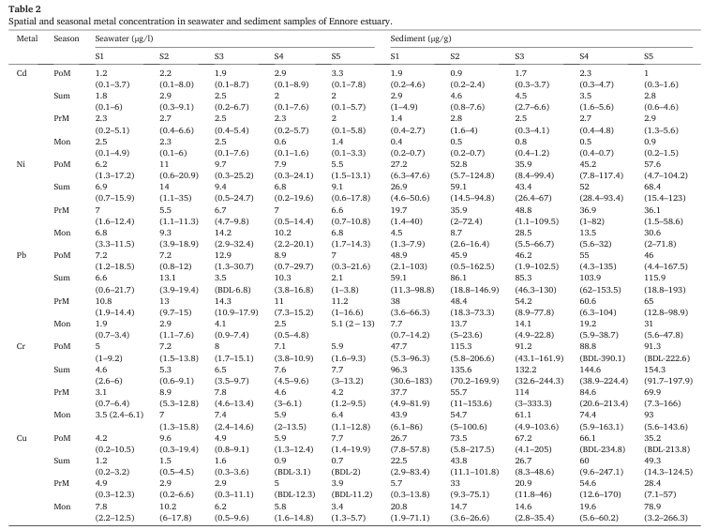

3.3 Metal concentration in sediment

# The average concentration of metals across all seasons and stations ranged from 64.4 to 112 μg/g.

# Chromium (Cr) had the highest average concentration (95.6 μg/g), followed by Lead (Pb), Copper (Cu), Nickel (Ni), and Cadmium (Cd).

# Higher levels of metals were observed during monsoon and post-monsoon seasons in the upstream of the estuary (stations 3 to 5).

3.4 Metal concentration in marine organisms

# Average metal concentrations varied across species:

* Fish (Mugil cephalus): Cr (4.6 μg/g), Cu (2.4 μg/g), Cd (2.21 μg/g), Pb (4.9 μg/g), Ni (2.6 μg/g)
* Crab (Scylla serrata): Higher than all other species (average: Cr - 11.4 μg/g, Cu - 22.1 μg/g)
* Oyster (Crassostrea madrasensis): Cr (13 μg/g), Cu (20.8 μg/g)
* Polychaete (Eunice spp.): Cr (18.8 μg/g), Cu (20.1 μg/g)

# Metal content order within a species (except fish): Cu > Cr > Pb > Ni > Cd

# Fish order (due to migration): Pb > Cr > Ni > Cu > Cd

# Seasonal variations:

* Crabs: Highest metals in monsoon/post-monsoon
* Oysters: Highest metals in monsoon
* Polychaetes: Highest metals in summer

3.5 Bioaccumulation factor (BAF)

BAFs (Bioaccumulation Factors) in Ennore Estuary

* Crabs bioaccumulate metals the most, followed by polychaetes, oysters, and then fish.
* Copper (Cu) has the highest BAF in all organisms except fish.
* Fish BAF order is different: Cadmium (Cd) > Lead (Pb) > Copper (Cu) > Chromium (Cr) > Nickel (Ni)
* During monsoon and post-monsoon seasons BAFs are in high.

.

* Order of BAFs: Crab > Polychaete > Oyster > Fish

3.6. Biota-sediment accumulation factor (BSAF)

# The average BSAF of metals varied from 0.2 to 2.4

# Crabs and oysters has highest BSAF for Cadmium (7.7 and 6.0)

# The higher BAFs are recorded during Monsoon and Post monsoon seasons.

# Metal concentrations in polychaetes :Cu>Cd>Cr>Ni>Pb.

# Metal concentration in Oysters in fishes : Cd > Cu > Pb > Cr > Ni.

# Metal concentration in Oysters in Crabs : Cd> Pb > Ni > Cr > Cu

3.7 Environmental quality indices

# During summer and Post monsoon Geoaccumulation values are higher .

# Based on Geoaccumulation index values sediments of ennore estuary

~ Heavily polluted with Cd.

~ Moderately to heavily polluted by Pb.

~ Moderately polluted by Cr and Cu.

~ Unpolluted by Ni.

# In ennore estuary the metal contamination level is classified based on Contamination factor.

# Highly contaminated-Cd,Pd

# Moderately contaminating -Ni

# Based on the enrichment factor degree of metal enrichment in the sediment of ennore estuary is categorized.

#Cd and Pb are significantly enriched

# Cr and Cu moderately enriched except in monsoon.

# Pollution load index indicates overall metal pollution levels.

# Ennore estuary is polluted by heavy metals (Cr,Cu,Cd,Pb,Ni)from industrial discharges,sewage,etc.

# Potential ecological risk index applied to assess the degree of risk for biological activities in ecosystem.

# As high the value indicates as risk.

# Potential ecological risk index values are ranged in between 40.6 and 268.

# Comparingly metal concentration are higher in sediments than water.

# Sediment plays a key role: Metal concentrations were higher in sediments compared to seawater.

# Organic matter (TOC) influences some metals: Cadmium (Cd) and Chromium (Cr) in sediment showed a positive correlation with TOC content, suggesting influence from organic matter sources.

# Certain metals are co-located: Copper (Cu), Chromium (Cr), Lead (Pb), and Nickel (Ni) in sediments were significantly correlated, indicating a common source or similar spatial distribution.

# Metal transfer from sediment to water: Seawater Cadmium (Cd) concentration is linked to sediment Copper (Cu) and Nickel (Ni) levels.

# Metal transfer to marine organisms: Copper (Cu) and Cadmium (Cd) in water correlate with their respective concentrations in fish. Similarly, Lead (Pb) in water is linked to Pb in fish tissue. Sediment Copper (Cu) and Lead (Pb) are related to Pb levels in polychaetes.

# Bioaccumulation observed: Copper (Cu) and Cadmium (Cd) concentrations are highly correlated between crab and polychaete, suggesting bioaccumulation of these metals. Lead (Pb) in crabs might be influenced by multiple metals (Cr, Cu, Ni) from polychaetes.

EVSA2

**NCTPS-NORTH CHENNAI THERMAL POWER STATION**

**@ Introduction**

# These plants uses fossil fuel to generate power.

# Heat removal is made by cooling water ,there are 2 ways

1. **Recycling cooling water :** This process uses cooling water to recycle water.
2. **Once through cooling :** Discharges heated water (8°C higher)into Ennore creek at 27.5m^3/s.

# Due to heat water pollution takes place.

# Tamilnadu electricity board operates a 600MW thermal power station at Ennore in North Chennai.

# Buoyancy: Floating

# Diffusion :Spreading

# Entrainment: Mixing

# Mixing and Dilution of these effluent occur due to turbulence that causes entrainment and diffusion.with the source of the turbulence with distance from the discharge point.

# Near the discharge point,the turbulence is primarily induced by the discharge momentum and buoyancy with local currents and boundaries modifying it.

# Far from the discharge point self induced turbulence decays and mixing is primarily driven by naturally ocean turbulence.

**@Materials and Methods**

**#** Ennore creek is located in the northeast coast of metropolitan Chennai city, Thiruvallur district,Tamilnadu,India.

# The total area of creek is 4 sq.km and nearly 400 meters wide.

# The creek channels connect to the Pullicat lake in the north and to the Kortalaiyar river in the south.

# Ennore thermal power station withdraws cooling water from the creek and diposes warm water into sea through marine outfall.

# The creek is also a source of cooling water for the North Chennai Thermal power Station.

# North Chennai Thermal power station unit discharges the cooling water into Buckingham canal which joins the Ennore Creek.

# The frequent closure of the Ennore mouth has resulted in insufficient tidal inflow and thus reduced cooling water for the thermal power plants.

# NCTPS has opted to discharge warm water back into creek through Buckingham Canal,to maintain water quantity in the creek.

# NCTPS has stopped withdrawing water from the creek and now intake water for cooling is taken inside Ennore port.

**@Ennore creek mouth**

# The Ennore creek mouth is influenced by seasonal circulation in the Bay of Bengal.

# Currents move along the coast towards the north from March to October and move towards the south from November to February.